Nitesh Joshi
E23CSEU1970
#

================================
#

LAB

8

-

GAN

Artistic

Image

Generation
#

================================
import

torch
import

torch.nn

as

nn
import

torchvision
import

torchvision.transforms

as

transforms
import

torchvision.utils

as

vutils
import

matplotlib.pyplot

as

plt
import

numpy

as

np
#

================================
#

Device

configuration
#

================================
device

=

torch.device
(
"cuda"

if

torch.cuda.is_available
(
)

else

"cpu"
)
#

================================
#

Hyperparameters
#

================================
batch_size

=

128
image_size

=

64
latent_dim

=

100
epochs

=

5
lr

=

0.0002
#

================================
#

Data

Preparation
#

================================
transform

=

transforms.Compose
(
[

transforms.Resize
(
image_size
)
,

transforms.ToTensor
(
)
,

transforms.Normalize
(
(
0.5
,
0.5
,
0.5
)
,
(
0.5
,
0.5
,
0.5
)
)
]
)
dataset

=

torchvision.datasets.CIFAR10
(

root=
'./data'
,

train=
True
,
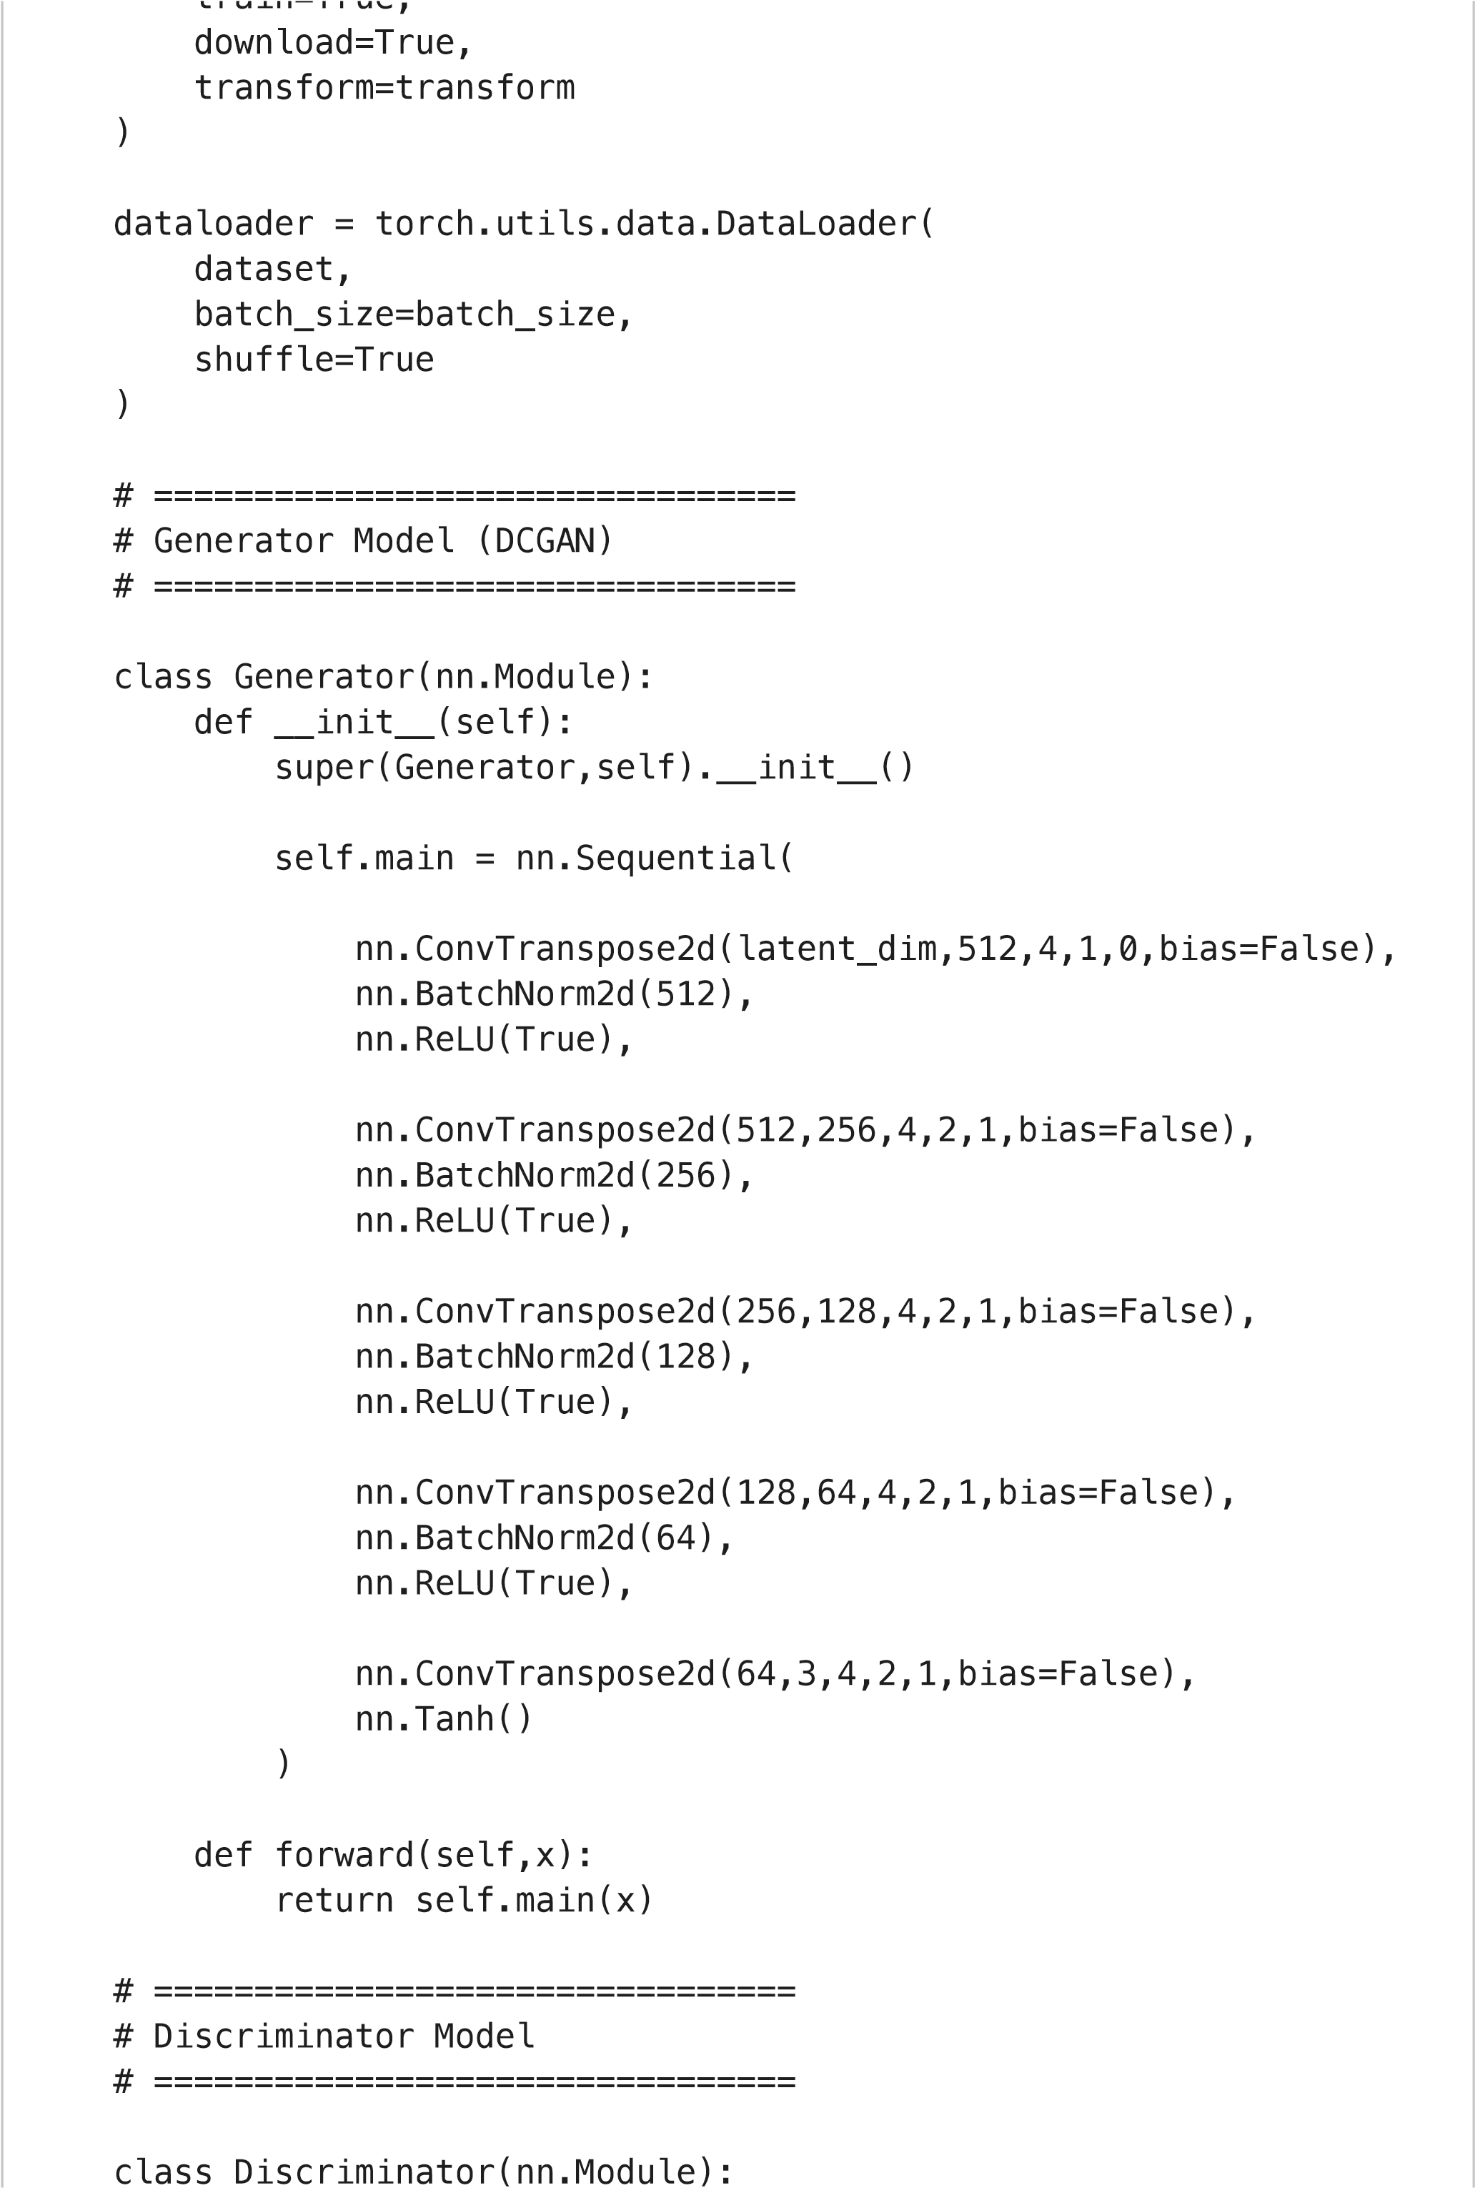
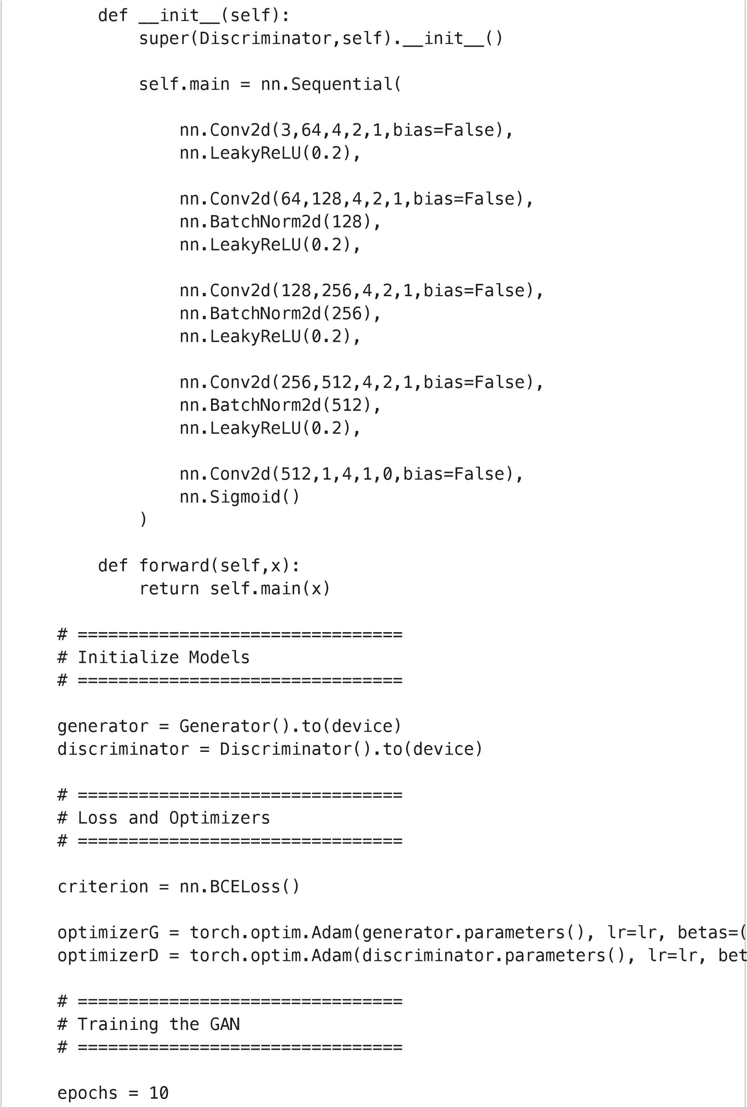
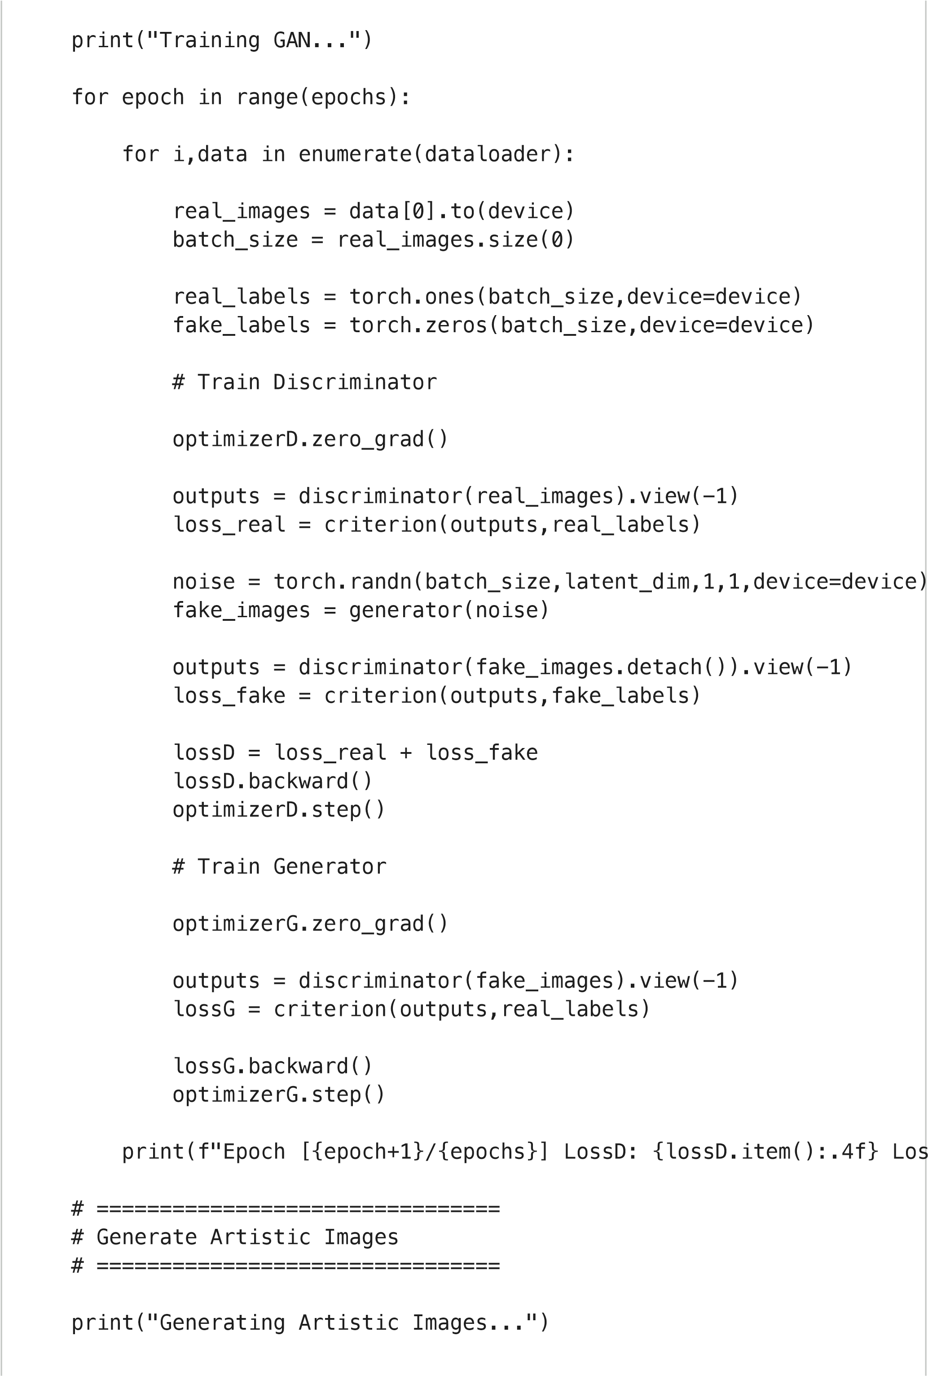
noise = torch.randn(10,latent_dim,1,1,device=device)
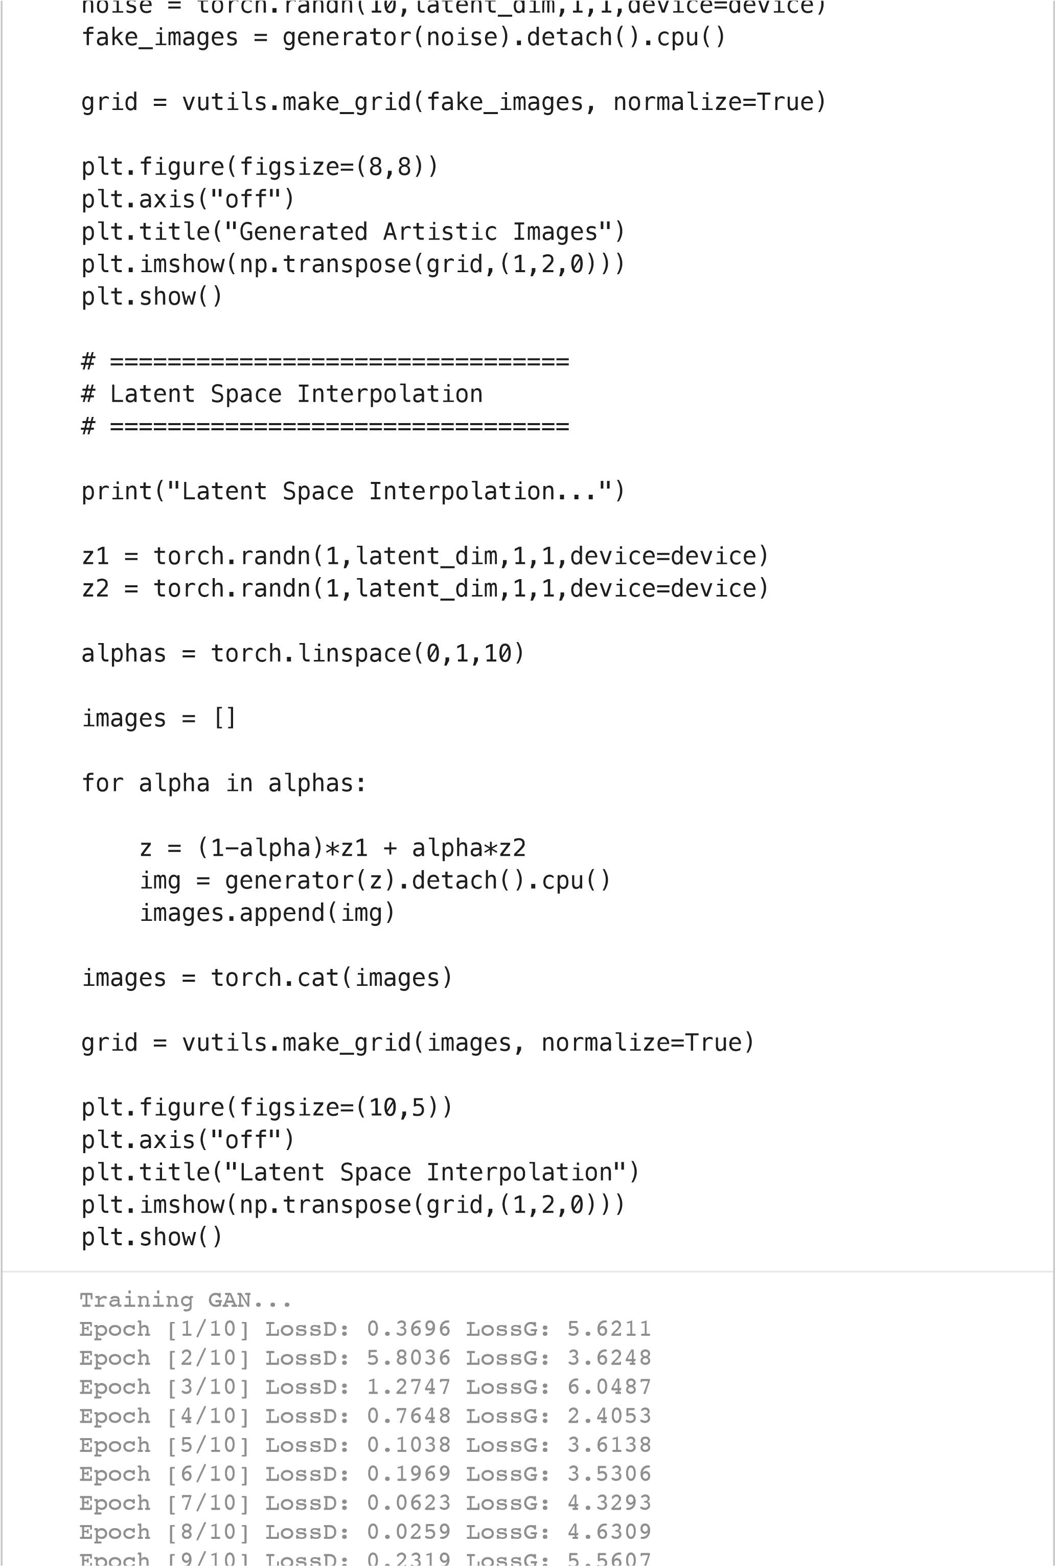
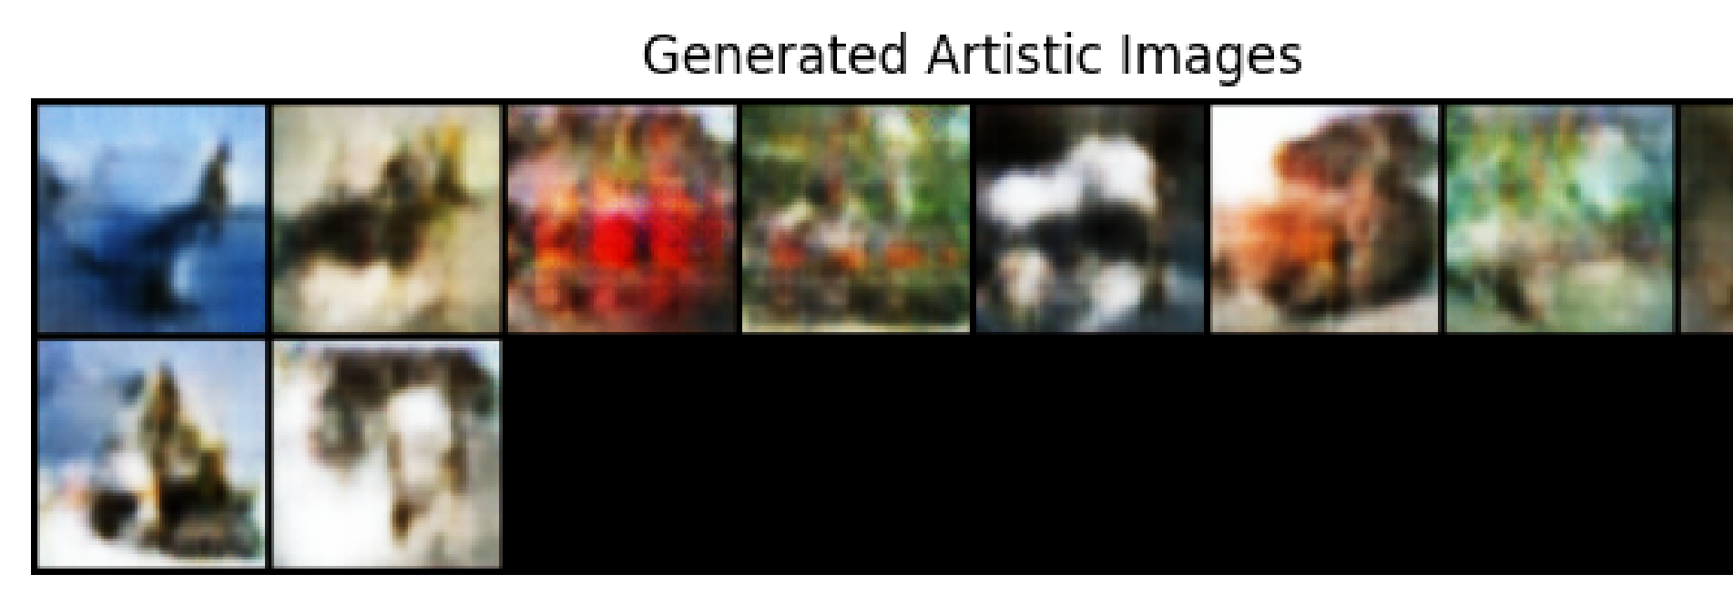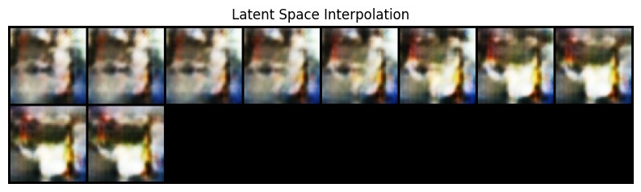
Epoch [9/10] LossD: 0.2319 LossG: 5.5607
Epoch [10/10] LossD: 0.0790 LossG: 4.1930
Generating Artistic Images...
Latent Space Interpolation...
Generated
Artistic
Images
Latent
Space
Interpolation

